

FEDERAL AVIATION ADMINISTRATION

AIRWORTHINESS DIRECTIVES

SMALL AIRCRAFT, ROTORCRAFT, GLIDERS,

BALLOONS, & AIRSHIPS

BIWEEKLY 2002-16

This electronic copy may be printed and used in lieu of the FAA biweekly paper copy.

U.S. Department of Transportation
Federal Aviation Administration
Regulatory Support Division
Delegation and Airworthiness Programs Branch, AIR-140
P. O. Box 26460
Oklahoma City, OK 73125-0460
FAX 405-954-4104

Biweekly 2002-01
2001-26-13 |  | Pilatus Aircraft | PC-7
2001-26-25 |  | Grob-Werke | Sailplane: G102 Club Astir III, G102 Club Astir IIIb, and G102 Standard Astir III
2002-01-02 |  | Turbomeca S.A. | Engine: Arrius 1A

Biweekly 2002-02
2000-20-19 | C, S 86-15-10R2 | Eurocopter France | Rotorcraft: AS-350B, BA, B1, B2, B3, C, D, and D1, and  AS-355E, F, F1, F2 and N
2001-25-51 | FR | MD Helicopters | Rotorcraft: MD900
2001-26-52 | FR | Eurocopter Deutschland | Rotorcraft: EC135
2001-26-53 | FR | Eurocopter France | Rotorcraft: AS350B, B1, B2, B3, BA, D, and AS355E
2002-01-05 |  | British Aerospace | HP.137 Jetstream Mk.1, Jetstream Series 200, Jetstream Series 3101, and Jetstream Model 3201
2002-01-06 |  | Eurocopter France | Rotorcraft: AS332L2
2002-01-07 |  | Bell Helicopter Textron Canada | Rotorcraft: 430
2002-01-09 |  | Pilatus Aircraft | PC-7, PC-12, and PC-12/45
2002-01-10 |  | Raytheon Aircraft | 65-90, 65-A90, B90, C90, C90A, 65-A90-1, 65-A90-4, E90, and H-90
2002-01-11 |  | Pilatus Britten-Norman | BN-2, BN-2A, BN-2A-2, BN-2A-3, BN-2A-6, BN-2A-8,  BN-2A-9, BN-2A-20, BN-2A-21, BN-2A-26, BN-2A-27,  BN-2B-20, BN-2B-21, BN-2B-26, BN-2B-27, BN-2T, BN-2T-4R,  BN2A MK. III, BN2A MK. III-2, and BN2A MK. III-3

Biweekly 2002-03
2001-25-04 |  | Honeywell International | Engine: LTS101-600A-2, LTS101-600A-3, LTP101-600A-1A, LTP101-700A-1A Turboprop
2001-26-54 | FR | Eurocopter France | Rotorcraft: EC 155B
2002-01-16 | S 86-24-11 &  86-25-04 | Fairchild Aircraft | SA26-AT, SA226-AT, SA226-T, SA226-T(B), SA226-TC, SA227-AC, SA227-AT, SA227-TT
2002-01-30 |  | Eurocopter France | Rotorcraft: SE 3130, SE 313B, SA 315B, SE 3160, SA 316B, SA 316C, SA 3180, SA 318B, SA 318C, and SA 319B
2002-01-31 | S 2000-22-51 | Bell Helicopter | Rotorcraft: HH-1K, TH-1F, TH-1L, UH-1A, UH-1B, UH-1E, UH-1F, UH-1H, UH-1L, and UH-1P, SW204, SW204HP, SW205, and SW205A-1
2002-02-01 |  | Eagle Aircraft PTY | 150B
2002-02-51 | E | Eurocopter France | Rotorcraft: AS350B, AS350BA, AS350B1, AS350B2, AS350B3, AS350C, AS350D, AS350D1, AS355E, AS355F, AS355F1, AS355F2, AS355N, and EC130 B4
2002-03-52 | E, S 2002-02-51 | Eurocopter France | Rotorcraft: AS350B, AS350BA, AS350B1, AS350B2, AS350B3, AS350C, AS350D, AS350D1, AS355E, AS355F, AS355F1, AS355F2, AS335N, and EC130 B4

Biweekly 2002-04
2001-26-55 | FR | Eurocopter France | Rotorcraft: AS350B, AS350B1, AS350B2, AS350BA, AS350B3, AS350C, AS350D, AS350D1, AS355E, AS355F, AS355F1, AS355F2, and AS355N
2002-02-10 |  | Pilatus Britten Norman | BN-2, BN-2A, BN-2A-2, BN-2A-3, BN-2A-6, BN-2A-8, BN-2A-9, BN-2A-20, BN-2A-21, BN-2A-26, BN-2A-27, BN-2B-20, BN-2B-21, BN-2B-26, BN-2B-27, BN-2T, and BN-2T-4R
2002-02-11 |  | Pilatus Britten Norman | BN-2, BN-2A, BN-2A-2, BN-2A-3, BN-2A-6, BN-2A-8, BN-2A-9, BN-2A-20, BN-2A-21, BN-2A-26, BN-2A-27, BN-2B-20, BN-2B-21, BN-2B-26, BN-2B-27, BN-2T, BN-2T-4R, BN2A MK.III, BN2A MK.III-2, and BN2A MK.III-3
2002-03-01 |  | Honeywell International | Engine: T5311A, T5311B, T5313B, T5317A, T5317B, and former military T53-L-11, T53-L-11A, T53-L-11B, T53-L-11C, T53-L-11D, T53-L-11A S/SA, T53-L-13B, T53-L-13B S/SA, T53-L-13B S/SB, and T53-L-703 Turboshaft
2002-03-02 | S 98-13-03 | British Aerospace | HP.137 Jetstream Mk.1, Jetstream Series 200, Jetstream Series 3101

Biweekly 2002-04 continued
2002-03-03 |  | Socata-Groupe Aerospatiale | TBM 700
2002-03-04 |  | Pilatus Britten Norman | BN-2, BN-2A, BN-2A-2, BN-2A-3, BN-2A-6, BN-2A-8, BN-2A-9, BN-2A-20, BN-2A-21, BN-2A-26, BN-2A-27, BN-2B-20, BN-2B-21, BN-2B-26, BN-2B-27, BN-2T, BN-2T-4R, BN2A MK.III, BN2A MK.III-2, and BN2A MK.III-3
2002-03-09 |  | Honeywell International | Engine: LTS101 Series Turboshaft and LTP101 Series Turboprop
2002-03-16 | S 2000-18-52 | Bell Helicopters (See AD) | OH-13E, OH-13H, and OH-13S
2002-04-51 | E | Textron Lycoming | Engine: LTIO-540 and TIO-540 (See AD)

Biweekly 2002-05
2002-04-07 |  | Eurocopter France | Rotorcraft: AS350BA and B2

Biweekly 2002-06
2002-03-09 | R1 | Honeywell International | Engine: LTS101 Series Turboshaft and LTP101 Series Turboprop
2002-03-52 | FR, S 2002-02-51 | Eurocopter France | Rotorcraft: AS350B, AS350BA, AS350B1, AS350B2, AS350B3, AS350C, AS350D, AS350D1, AS355E, AS355F, AS355F1, AS355F2, AS355N, and EC130 B4
2002-05-04 | S 77-15-06 | Socata-Groupe Aerospatiale | MS 892A-150, MS 892E-150, MS 893A, MS 893E, MS 894A, MS 894E, Rallye 150T, and Rallye 150ST
2002-05-05 |  | Cirrus Design Corporation | SR20 and SR22
2002-05-06 | COR, S 86-09-11 | Sikorsky Aircraft Corporation | Rotorcraft: S-76A
2002-06-04 |  | Eurocopter France | Rotorcraft: AS350B, AS350B1, AS350B2, AS350B3, AS350BA, AS350C, AS350D, AS350D1, AS355E, AS355F, AS355F1, AS355F2, and AS355N
2002-06-05 |  | Transport Category Airplanes  Rockwell Collins | Appliance: Mode C 621A-3 Air Traffic Control (ATC) Transponder(s)
2002-06-08 |  | Rolls-Royce Corp. | Engine: 250-C28, -C28B, and -C28C
2002-06-52 | E, S 2000-02-12 | Bell Helicopter Textron Canada | Rotorcraft: 407

Biweekly 2002-07
2002-06-06 |  | Rockwell Collins, Inc. | Appliance: TDR-94 and TDR-94D Mode S Transponders
2002-06-10 |  | Pilatus Aircraft | PC-12 and PC-12/45
2002-07-01 |  | Cessna | P206C, TP206C, P206D, TP206D, P206E, TP206E, U206C, TU206C, U206D, TU206D, U206E, TU206E, U206F, TU206F, U206G, TU206G, 207, T207, 207A, T207A, 210G, 210H, 210J, 210K, T210K, 210L, T210L, 210M, T210M, 210N, T210N, P210N, T210G, T210H, T210J

Biweekly 2002-08
2001-24-51 | FR | MD Helicopters, Inc. | Rotorcraft: 600N
2002-06-52 | FR, S 2000-02-12 | Bell Helicopter Textron Canada | Rotorcraft: 407
2002-08-01 |  | Fairchild Aircraft, Inc. | SA226-AT, SA226-T, SA226-T(B), SA226-TC, SA227-AC, SA227-AT, and SA227-TT
2002-08-02 | S 2001-20-14 | Fairchild Aircraft, Inc. | SA226-AT, SA226-T, SA226-T(B), SA226-TC, SA227-AC, SA227-AT, SA227-TT, and SA227-TT(300)
2002-08-03 | S 2001-22-01 | Enstrom Helicopter Corp. | Rotorcraft: F-28, F-28A, F-28C, F-28F, 280, 280C, 280F and 280FX

Biweekly 2002-09
2001-25-52 | FR, S 76-18-01 | Schweizer Aircraft Corp. | Rotorcraft: 269A, 269A-1, 269B, 269C, and TH-55A
2002-03-52 | FR, COR, S 2002-02-51 | Eurocopter France | Rotorcraft: AS350B, AS350BA, AS350B1, AS350B2, AS350B3, AS350C, AS350D, AS350D1, AS355E, AS355F, AS355F1, AS355F2, AS355N, and EC130 B4
2002-08-02 | COR,  S 2001-20-14 | Fairchild Aircraft, Inc. | SA226-AT, SA226-T, SA226-T(B), SA226-TC, SA227-AC, SA227-AT, SA227-TT, and SA227-TT(300)
2002-08-04 |  | Piaggio Aero Industries S.p.A. | P-180
2002-08-16 | S 2001-19-51 | Eurocopter France | Rotorcraft: SA341G, SA342J, and SA-360C
2002-08-53 | E | Bell Helicopter Textron, Inc. | Rotorcraft: 205A, A-1 and B
2002-08-54 | E | Bell Helicopter Textron Canada | Rotorcraft: 222, 222B, 222U, and 230
2002-09-03 |  | Eurocopter France | Rotorcraft: AS332L2
2002-09-04 |  | Bell Helicopter Textron, Inc. | 205A, 205A-1, 205B, 212, 412, 412EP, and 412CF
Biweekly 2002-10
2002-09-08 | S 77-12-06 R2 | Hartzell Propellers | Propellers: ( )HC-( )( )Y( )-( )( )( ) Compact Series
2002-09-09 |  | Honeywell International | Engine: T53 Series
2002-09-11 | COR,  S 2001-05-03 | SOCATA | TBM 700
2002-09-12 | COR | Raytheon | C90A
2002-09-13 |  | Cessna | 441
2002-09-51 | E, S 2002-08-53 | Bell Helicopters | Rotorcraft: 204B, 205A, A-1, and B
2002-10-05 | S 2001-07-09 | MD Helicopters | Rotorcraft: MD-900

Biweekly 2002-11
2002-10-13 |  | Raytheon Aircraft Company | 58P, 60, A60, B60, and 65-88
2002-10-14 |  | Bombardier-Rotax GmbH | Engine: 914 F Series
2002-11-01 |  | Eurocopter Deutschland | Rotorcraft: EC135
2002-11-02 |  | Raytheon Aircraft Company | 390
2002-11-05 |  | Air Tractor, Inc. | AT-400, AT-401, AT-401B, AT-402, AT-402A, AT-402B, AT-501, AT-802, and AT-802A

Biweekly 2002-12
2002-11-03 |  | Air Tractor, Inc. | AT-502, AT-502A, AT-502B, AT-503A
2002-11-07 |  | Raytheon Aircraft | E55, E55A, A56TC, 58, 58A, 58P, 58PA, 58TC, and 58TCA
2002-11-09 |  | Bell Helicopter | Rotorcraft: 407
2002-11-10 | S 2001-25-08 | Sikorsky | Rotorcraft: S-70A, S-70C
2002-12-02 |  | Eurocopter France | Rotorcraft: AS332L2
2002-12-03 |  | Eurocopter France | Rotorcraft: AS332L2

Biweekly 2002-13
2002-11-03 | COR | Air Tractor, Inc. | AT-502, AT-502A, AT-502B, AT-503A
2002-12-07 | S 2000-18-53 | Textron Lycoming | Engine: O–320–H1AD, –H1BD, –H2AD, –H2BD, –H3AD, -H3BD, (L)O–360,–A1AD, –A1F6D, –A1G6D, –A1LD, –A3AD, –A4AD, –A5AD, –E1A6D, IO–360–A1B6D, –A1D6D, –A3B6D, –A3D6D, –C1E6D, –J1AD, –J1A6D, (L)TO–360,–A1A6D, -C1A6D, –E1A6D, –F1A6D, TIO–360–C1A6D, (L)HIO-360-E1AD, –E1BD, –F1AD, O–540–H1A5D, –H1B5D, -H2A5D, –H2B5D, –J1A5D, –J1B5D, –J1C5D, –J1D5D, -J2A5D, –J2B5D, –J2C5D, –J2D5D, –J3A5D, –J3C5D, –L3C5D, IO-540-C4D5D, –K1A5D, –K1B5D, –K1E5D, –K1F5D, -K1G5D, –K1J5D, –L1A5D, -L1B5D, –M1A5D, –M1B5D, –M2A5D, -T4A5D, –T4B5D, –T4C5D, –U1A5D, -U1B5D, –V4A5D, -W1A5D, –W3A5D, (L)TIO–540–K1AD, –S1AD, –AA1AD, -AB1AD, –AB1BD, –F2BD, –J2BD, –N2BD, -R2AD, –T2AD, -V2AD, AEIO–540–L1B5D, TIO–541–E Series, TIGO–541–D1A, –D1B, –E1A, IO–720–A1BD, –B1BD, –C1BD, –D1BD, –D1CD
2002-12-09 |  | Honeywell International | Engine: TPE331-11U, -12B, -12JR, -12UA, -12UAR, and -12UHR Series Turboprop
2002-12-14 | S 99-23-07 | Eurocopter France | Rotorcraft: SA330F, G, SA330J, AS332C, L, and L1
2002-13-04 | S 2000-11-51 | Teledyne Continental | Engine: C-125, C145, O-300, IO-360, TSIO-360, and LTSIO-520-AE Series Reciprocating
2002-13-05 |  | MD Helicopters | Rotorcraft: 369D, 369E, 369F, and 369FF
2002-13-06 |  | Eurocopter Deutschland | Rotorcraft: BO-105A, BO-105C, BO-105 C-2, BO-105 CB-2, BO-105 CB-4, BO-105S, BO-105 CS-2, BO-105 CBS-2, BO-105 CBS-4, and BO-105LS A-1
2002-13-51 | E | Bell Helicopters | Rotorcraft: HH-1K, TH-1F, TH-1L, UH-1A, UH-1B, UH-1E, UH-1F, UH-1H, UH-1L, UH-1P; SW204, SW204HP, SW205, and SW205A-1

Biweekly 2002-14
2002-13-02 |  | Air Tractor | AT-300, AT-301, AT-302, and AT-400A
2002-13-07 |  | Honeywell, Inc. | Appliance: Inertial Reference Unit
2002-13-08 |  | de Havilland | DHC-2 Mk.I, DHC-2 Mk. II, and DHC-2 Mk. III
2002-13-11 |  | Eurocopter France | Rotorcraft: EC120B
2002-14-01 |  | Eurocopter France | Rotorcraft: AS332L and AS332L1
2002-14-17 | S 99-12-01 | Eurocopter Deutschland | Rotorcraft: EC135
2002-14-18 |  | Glaser-Dirks Flugzeugbau | Sailplane: DG-400 and DG-800A
2002-14-51 | E | Agusta S.p.A | Rotorcraft: A109E and A119

Biweekly 2002-15
2002-13-04 | COR  S 2000-11-51 | Teledyne Continental | Engine: C-125, C145, O-300, IO-360, TSIO-360, and LTSIO-520-AE Series Reciprocating
2002-14-19 |  | Rockwell Collins | Appliance: Air Data Computers (ADC)
2002-14-22 | COR | Pilatus Aircraft | PC-12 and PC-12/45
2002-14-26 |  | Turbomeca S.A. | Engine: Arriel Models 1A, 1A1, 1B, 1D, and 1D1 Turboshaft
2002-14-28 |  | de Havilland | DHC-2, Mk. I, DHC-2 Mk. II, and DHC-2 Mk. III
2002-15-01 |  | Diamond Aircraft | Sailplane: H-36 ''Dimona'', HK 36 R ''Super Dimona'', HK 36 TC, HK 36 TS, HK 36 TTC, HK 36 TTC-ECO, HK 36 TTC-ECO (Restricted Category), and HK 36 TTS
2002-15-02 |  | Hamilton Sundstrand Power Sys. | Appliance: Auxiliary Power Units (APU's)
2002-15-51 | E | Sikorsky | Rotorcraft: S76A, B, and C

Biweekly 2002-16
2002-08-54 | FR | Bell Helicopter | Rotorcraft: 222, 222B, 222U, 230
2002-09-51 | FR, S 2002-08-53 | Bell Helicopter | Rotorcraft: 204B, 205A, A-1, and B
2002-13-51 | FR | Bell Helicopter, (See AD) | Rotorcraft: HH-1K, TH-1F, TH-1L, UH-1A, UH-1B, UH-1E, UH-1F, UH-1H, UH-1L, and UH-1P; SW204, SW204HP, SW205, and SW205A-1
2002-15-04 |  | Honeywell International | Engine: T5313B, T5317 Series, and former military T53 Series Turboshaft
2002-15-05 |  | Turbomeca | Engine: Makila 1 A, 1 A1, and 1 A2 Turboshaft
2002-15-06 |  | Air Tractor | AT-802 and AT-802A
2002-15-07 |  | MD Helicopters | Rotorcraft: MD900
2002-15-08 |  | Eurocopter France | Rotorcraft: EC120B, EC155B, SA330F, SA330G, SA330J, AS332C, AS332L, AS332L1, AS332L2, AS350B, AS350BA, AS350B1, AS350B2, AS350B3, AS350D, AS355E, AS355F, AS355F1, AS355F2, AS355N, AS-365N2, AS 365 N3, SA-365N, and SA-365N1

BW 2002-16

BELL HELICOPTER TEXTRON CANADA
AIRWORTHINESS DIRECTIVE
FINAL RULE
SMALL AIRCRAFT, ROTORCRAFT, GLIDERS, BALLOONS, & AIRSHIPS

2002-08-54 Bell Helicopter Textron Canada: Amendment 39-12835, Docket No. 2002-SW-22-AD.

Applicability: The following model helicopters with the listed part number (P/N) installed, certificated in any category:

Model | With hub assembly P/N | With grip assembly P/N | With pitch horn assembly P/N
(1) 222 or 222B | 222–011–101–103, -105, -107, or -109 | 222–010–104–105 | 222–011–104–101
(1) 222 or 222B | 222–012–101–103, or -107 | 222–012–104–101 | 222–012–102–101
(2) 222U | 222–011–101–105, -107, or -109 | 222–010–104–105 | 222–011–104–101
(2) 222U | 222–012–101–103, OR -107 | 222–012–104–101 | 222–012–102–101
(3) 230 | 222–012–101–105, or -109 | 222–012–104–101 | 222–012–102–101

Note 1: This AD applies to each helicopter identified in the preceding applicability provision, regardless of whether it has been otherwise modified, altered, or repaired in the area subject to the requirements of this AD. For helicopters that have been modified, altered, or repaired so that the performance of the requirements of this AD is affected, the owner/operator must request approval for an alternative method of compliance in accordance with paragraph (d) of this AD. The request should include an assessment of the effect of the modification, alteration, or repair on the unsafe condition addressed by this AD; and if the unsafe condition has not been eliminated, the request should include specific proposed actions to address it.

Compliance: Required as indicated, unless accomplished previously.
To prevent failure of the grip or pitch horn and subsequent loss of control of the helicopter, if either the grip or pitch horn has accumulated 1250 or more hours time-in-service (TIS) since initial installation on any helicopter, accomplish the following:

(a) Before further flight and thereafter at intervals not to exceed 8 hours TIS:
(1) Wipe clean the main rotor grip and pitch horn surfaces to remove grease and dirt in the check area as shown in Figure 1 of this AD:

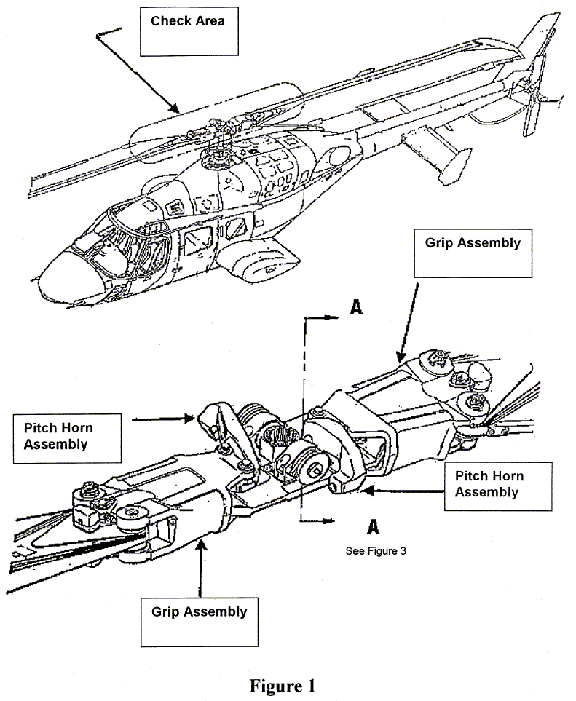
(2) Visually check both main rotor grips for a crack, paying particular attention to the inboard and outboard tangs/portions of the grip, which are in direct contact with the pitch horns and the main rotor blades. Check the area to at least 3 inches beyond the grip/pitch and grip/blade contact areas as shown in Figure 2 of this AD:
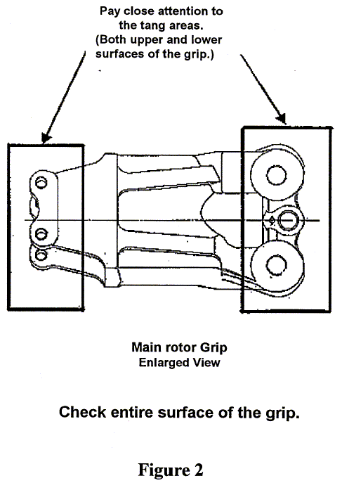
(3) Visually check all visible portions of each pitch horn for a crack. Pay particular attention to the attachment lugs of the pitch horns, which are in direct contact with the inboard tangs of the main rotor grips, as shown in Figure 3 of this AD, and the four large bolt cutouts, as shown in Figure 4 of this AD:
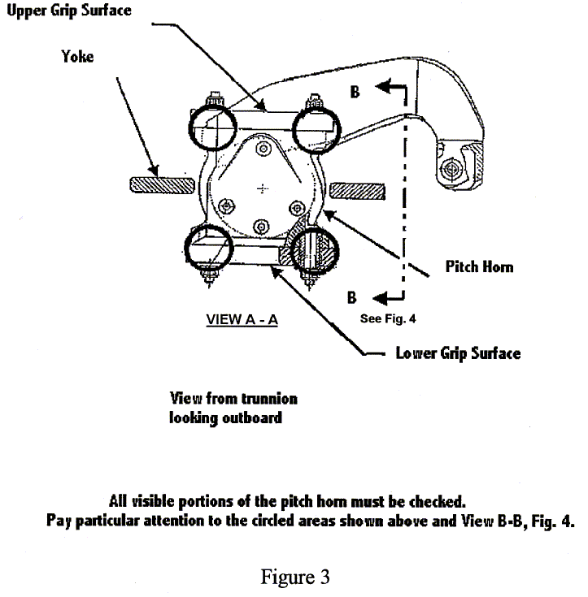
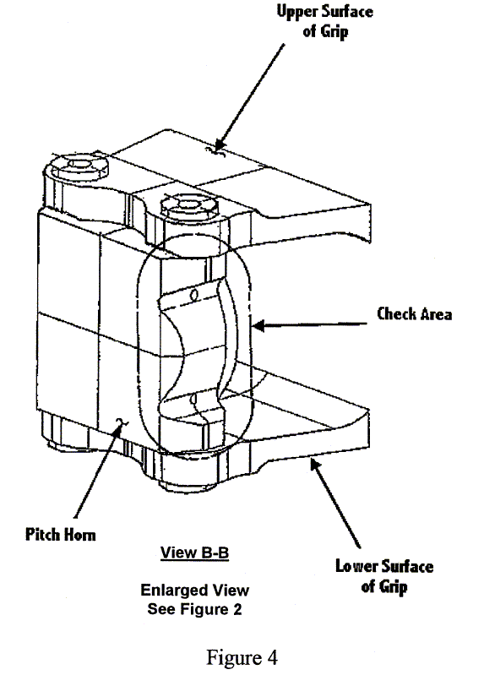

(4) An owner/operator (pilot) may perform the visual check required by this AD. The pilot must enter compliance with paragraph (a) of this AD into the helicopter maintenance records in accordance with 14 CFR 43.11 and 91.417(a)(2)(v)). A pilot may perform this check because it involves only a visual check for a crack in the grip or pitch horn and can be performed equally well by a pilot or a mechanic.

(b) Within 7 days or 10 hours TIS, whichever occurs first, and thereafter at intervals not to exceed 25 hours TIS, using a 10-power or higher magnifying glass, visually inspect each grip and pitch horn for a crack in accordance with the Accomplishment Instructions, Part II, paragraphs 1 and 2, of Bell Helicopter Textron Alert Service Bulletin Nos. 222U-02-64, 222-02-93, and 230-02-26, all dated April 1, 2002, as applicable.

(c) If a crack is found, replace the unairworthy grip or pitch horn with an airworthy part before further flight.

(d) An alternative method of compliance or adjustment of the compliance time that provides an acceptable level of safety may be used if approved by the Manager, Regulations Group, FAA. Operators shall submit their requests through an FAA Principal Maintenance Inspector, who may concur or comment and then send it to the Manager, Regulations Group.

Note 2: Information concerning the existence of approved alternative methods of compliance with this AD, if any, may be obtained from the Regulations Group.

(e) Special flight permits may be issued in accordance with 14 CFR 21.197 and 21.199 to operate the helicopter to a location where the inspection requirements of paragraph (b) of this AD can be accomplished.

(f) The inspection shall be done in accordance with the Accomplishment Instructions, Part II, paragraphs 1 and 2, of Bell Helicopter Textron Alert Service Bulletin Nos. 222U-02-64, 222-02-93, and 230-02-26, all dated April 1, 2002, as applicable. This incorporation by reference was approved by the Director of the Federal Register in accordance with 5 U.S.C. 552(a) and 1 CFR part 51. Copies may be obtained from Bell Helicopter Textron Canada, 12,800 Rue de l'Avenir, Mirabel, Quebec J7J1R4, telephone (450) 437-2862 or (800) 363-8023, fax (450) 433-0272. Copies may be inspected at the FAA, Office of the Regional Counsel, Southwest Region, 2601 Meacham Blvd., Room 663, Fort Worth, Texas; or at the Office of the Federal Register, 800 North Capitol Street, NE., suite 700, Washington, DC.

(g) This amendment becomes effective on August 21, 2002, to all persons except those persons to whom it was made immediately effective by Emergency AD 2002-08-54, issued May 2, 2002, which contained the requirements of this amendment.

Note 3: The subject of this AD is addressed in Transport Canada (Canada) AD CF-2002-23, dated April 2, 2002.

FOR FURTHER INFORMATION CONTACT: Charles Harrison, Aviation Safety Engineer, FAA, Rotorcraft Directorate, Rotorcraft Standards Staff, Fort Worth, Texas 76193-0110, telephone (817) 222-5128, fax (817) 222-5961.

Issued in Fort Worth, Texas, on July 25, 2002.
Eric Bries,
Acting Manager, Rotorcraft Directorate, Aircraft Certification Service.
[FR Doc. 02-19486 Filed 8-5-02; 8:45 am]
BILLING CODE 4910-13-P
BW 2002-16

BELL HELICOPTER TEXTRON, INC
AIRWORTHINESS DIRECTIVE
FINAL RULE
SMALL AIRCRAFT, ROTORCRAFT, GLIDERS, BALLOONS, & AIRSHIPS

2002-09-51 Bell Helicopter Textron, Inc.: Amendment 39-12839. Docket No. 2002-SW-24-AD. Supersedes Emergency AD 2002-08-53, Docket No. 2002-SW-23-AD.

Applicability: Model 204B, 205A, A-1, and B helicopters, with tail rotor (T/R) grip, part number (P/N) 205-011-711-101, installed, certificated in any category.

Note 1: This AD applies to each helicopter identified in the preceding applicability provision, regardless of whether it has been otherwise modified, altered, or repaired in the area subject to the requirements of this AD. For helicopters that have been modified, altered, or repaired so that the performance of the requirements of this AD is affected, the owner/operator must request approval for an alternative method of compliance in accordance with paragraph (c) of this AD. The request should include an assessment of the effect of the modification, alteration, or repair on the unsafe condition addressed by this AD; and if the unsafe condition has not been eliminated, the request should include specific proposed actions to address it.

Compliance: Required before further flight, unless accomplished previously.
To prevent failure of the T/R grip and subsequent loss of helicopter control, accomplish the following:

(a) Clean the T/R grip.

(b) Determine if the T/R grip is made of steel by placing a magnet on the exterior of the main body of the T/R grip. Do not make this determination by placing the magnet on the steel bushing or steel interior liner. If the main body of the T/R grip is not made of steel, replace it with an airworthy steel T/R grip. Only replacement T/R grips made of steel are eligible for installation.

(c) An alternative method of compliance or adjustment of the compliance time that provides an acceptable level of safety may be used if approved by the Manager, Rotorcraft Certification Office, FAA. Operators shall submit their requests through an FAA Principal Maintenance Inspector, who may concur or comment and then send it to the Manager, Rotorcraft Certification Office.

(d) Special flight permits may be issued in accordance with 14 CFR 21.197 and 21.199 to operate the helicopter to a location where the requirements of this AD can be accomplished.

(e) This amendment becomes effective on August 22, 2002, to all persons except those persons to whom it was made immediately effective by Emergency AD 2002-09-51, issued May 9, 2002, which contained the requirements of this amendment.

FOR FURTHER INFORMATION CONTACT: Kennedy Jones, Aviation Safety Engineer, FAA, Rotorcraft Directorate, Rotorcraft Certification Office, Fort Worth, Texas 76193-0170, telephone (817) 222-5148, fax (817) 222-5783.

Issued in Fort Worth, Texas, on July 26, 2002.
Eric Bries,
Acting Manager, Rotorcraft Directorate, Aircraft Certification Service.
[FR Doc. 02-19875 Filed 8-6-02; 8:45 am]
BILLING CODE 4910-13-P
BW 2002-16

BELL HELICOPTER
AIRWORTHINESS DIRECTIVE
FINAL RULE
SMALL AIRCRAFT, ROTORCRAFT, GLIDERS, BALLOONS, & AIRSHIPS

2002-13-51 Arrow Falcon Exporters, Inc. (previously Utah State University); Firefly Aviation Helicopter Services (previously Erickson Air-Crane Co.); Garlick Helicopters, Inc.; Global Helicopter Technology, Inc.; Hagglund Helicopters, LLC (previously Western International Aviation, Inc.); Hawkins and Powers Aviation, Inc.; International Helicopters, Inc.; Robinson Air Crane, Inc.; Smith Helicopters; Southern Helicopter, Inc.; Southwest Florida Aviation; Tamarack Helicopters, Inc. (previously Ranger Helicopters Services, Inc.); U.S. Helicopter, Inc.; and Williams Helicopter Corporation (previously Scott Paper Co.): Amendment 39-12836. Docket No. 2002-SW-21-AD.

Applicability: Model HH-1K, TH-1F, TH-1L, UH-1A, UH-1B, UH-1E, UH-1F, UH-1H, UH-1L, and UH-1P; Southwest Florida Aviation SW204, SW204HP, SW205, and SW205A-1 helicopters manufactured by Bell Helicopter Textron, Inc. for the Armed Forces of the United States, with tail rotor (T/R) grip, part number 205-011-711-101, installed, certificated in any category.

Note 1: This AD applies to each helicopter identified in the preceding applicability provision, regardless of whether it has been otherwise modified, altered, or repaired in the area subject to the requirements of this AD. For helicopters that have been modified, altered, or repaired so that the performance of the requirements of this AD is affected, the owner/operator must request approval for an alternative method of compliance in accordance with paragraph (c) of this AD. The request should include an assessment of the effect of the modification, alteration, or repair on the unsafe condition addressed by this AD; and if the unsafe condition has not been eliminated, the request should include specific proposed actions to address it.

Compliance: Required before further flight, unless accomplished previously.
To prevent failure of the T/R grip and subsequent loss of control of the helicopter, accomplish the following:

(a) Clean the T/R grip.

(b) Determine if the T/R grip is made of steel by placing a magnet on the exterior of the main body of the T/R grip. Do not make this determination by placing the magnet on the steel bushing or steel interior liner. If the main body of the T/R grip is not made of steel, replace it with an airworthy steel T/R grip. Only replacement T/R grips made of steel are eligible for installation.

(c) An alternative method of compliance or adjustment of the compliance time that provides an acceptable level of safety may be used if approved by the Manager, Rotorcraft Certification Office, FAA. Operators shall submit their requests through an FAA Principal Maintenance Inspector, who may concur or comment and then send it to the Manager, Rotorcraft Certification Office.

Note 2: Information concerning the existence of approved alternative methods of compliance with this AD, if any, may be obtained from the Rotorcraft Certification Office.

(d) Special flight permits may be issued in accordance with 14 CFR 21.197 and 21.199 to operate the helicopter to a location where the requirements of this AD can be accomplished.

(e) This amendment becomes effective on August 19, 2002, to all persons except those persons to whom it was made immediately effective by Emergency AD 2002-13-51, issued June 27, 2002, which contained the requirements of this amendment.

FOR FURTHER INFORMATION CONTACT: Kennedy Jones, Aviation Safety Engineer, FAA, Rotorcraft Directorate, Rotorcraft Certification Office, Fort Worth, Texas 76193-0170, telephone (817) 222-5148, fax (817) 222-5783.

Issued in Fort Worth, Texas, on July 25, 2002.
Eric Bries,
Acting Manager, Rotorcraft Directorate, Aircraft Certification Service.
[FR Doc. 02-19489 Filed 8-1-02; 8:45 am]
BILLING CODE 4910-13-U
BW 2002-16

HONEYWELL INTERNATIONAL, INC.,
AIRWORTHINESS DIRECTIVE
ENGINE
SMALL AIRCRAFT, ROTORCRAFT, GLIDERS, BALLOONS, & AIRSHIPS

2002-15-04 Honeywell International, Inc., (formerly AlliedSignal, Inc. and Textron Lycoming) T5313B, T5317 Series, and T53 Series Turboshaft Engines: Amendment 39-12832. Docket No. 2000-NE-32-AD.

Applicability: This airworthiness directive (AD) is applicable to Honeywell International, Inc., (formerly AlliedSignal, Inc., and Textron Lycoming) T5313B series, T5317 series, and former military T53 series, turboshaft engines with centrifugal compressor impellers having serial numbers (SN's) 83317, 83327, 83328, or 83330 installed. These engines are installed on, but not limited to Bell Helicopter Textron 204, 205, and 209 series, and Kaman K-1200 series helicopters, and the following surplus military helicopters that have been certified in accordance with §§21.25 or 21.27 of the Federal Aviation Regulations (14 CFR 21.25 or 21.27): Bell Helicopter Textron manufactured AH-1, UH-1, and SW-204/205 (UH-1) series.

Note 1: This AD applies to each engine identified in the preceding applicability provision, regardless of whether it has been modified, altered, or repaired in the area subject to the requirements of this AD. For engines that have been modified, altered, or repaired so that the performance of the requirements of this AD is affected, the owner/operator must request approval for an alternative method of compliance in accordance with paragraph (i) of this AD. The request should include an assessment of the effect of the modification, alteration, or repair on the unsafe condition addressed by this AD; and, if the unsafe condition has not been eliminated, the request should include specific proposed actions to address it.

Compliance: Compliance with this AD is required as indicated, unless already done.
To prevent premature failure of the impellers from being operated beyond their design service life, which could result in an uncontained engine failure, in-flight shutdown, or damage to the helicopter, do the following:

Life Limits

(a) When conducting a revised centrifugal compressor impeller operating cycle count on impellers having SN's 83317, 83327, 83328, or 83330, consider these impellers to be centrifugal compressor impeller P/N 1-100-078-07. The life limit must use the value as if these centrifugal compressor impellers are P/N 1-100-078-07.

Revised Operating Cycle Count (Prorate) for T53 Engines

(b) For T5313B series, T5317 series, and former military T53 series engines, within 25 operating cycles or 7 calendar days, whichever occurs first, after the effective date of this AD, perform the following:
(1) Conduct a revised centrifugal compressor impeller operating cycle count (prorate) in accordance with paragraph 2.E.of the Honeywell International, Inc. Service Bulletin (SB) that applies to the engine, from the following list:
(i) For T53-L-13B series engines, use SB T53-L-13B-0020, Revision 3, dated October 25, 2001.
(ii) For T53-L-13B/D engines, use SB T53-L-13B/D-0020, Revision 1, dated April 25, 2001.
(iii) For T53-L-703 engines, use SB T53-L-703-0020, Revision 1, dated April 25, 2001.
(iv) For T5313B series and T5317 series engines, use SB T531B/17-0020, Revision 6, dated May 2, 2001.
(2) Remove from service centrifugal compressor impellers with SN's 83317, 83327, 83328, or 83330, that exceed their new life limit as calculated in accordance with paragraph (b)(1) of this AD.

Impeller Marking

(c) At the next access to the centrifugal compressor impeller, mark the impeller by vibropeening a line over the -14 suffix, and vibropeen a -07 suffix immediately following the -14. Use the following vibropeening parameters:
(1) Vibropeen to a depth of 0.001-0.006 inch.
(2) Do not vibropeen within 0.30 inch of corners, fillets, or sharp edges.

Definition

(d) For the purpose of this AD, access to the centrifugal compressor impeller is defined as whenever the turboshaft engine is disassembled sufficiently as specified by the applicable maintenance manual, to expose the compressor impeller for marking in accordance with paragraph (c) of this AD.

Inspection of Impellers on T5313B and T5317 Series Engines

(e) For T5313B and T5317 series engines, inspect centrifugal compressor impellers having SN's 83317, 83327, 83328, or 83330, for cracks in accordance with the Accomplishment Instructions of Textron Lycoming SB No. T5313B/17-0052, Revision 2, dated December 16, 1993, as follows:
(1) For those centrifugal compressor impellers installed on AlliedSignal, Inc. Model T5313B engines, accomplish the following:
(i) For centrifugal compressor impellers with equal to or greater than 4,600 cycles in service (CIS) on the effective date of this AD, initially inspect within 200 CIS after the effective date of this AD.
(ii) For those centrifugal compressor impellers with less than 4,600 CIS on the effective date of this AD, initially inspect no later than 4,800 CIS.
(2) For those centrifugal compressor impellers installed on AlliedSignal, Inc. T5317 series engines, accomplish the following:
(i) For those centrifugal compressor impellers with equal to or greater than 3,500 CIS on the effective date of this AD, initially inspect within 200 CIS after the effective date of this AD.
(ii) For those centrifugal compressor impellers with less than 3,500 CIS on the effective date of this AD, initially inspect no later than 3,700 CIS.
(3) Centrifugal compressor impellers found cracked in accordance with the Accomplishment Instructions of Textron Lycoming SB No. T5313B/17-0052, Revision 2, dated December 16, 1993, must be removed from service and replaced with a serviceable part that does not exceed the life limit.
(4) If no cracks are detected, perform repetitive inspections of the centrifugal compressor impellers at intervals not to exceed 500 CIS since last inspection in accordance with the Accomplishment Instructions of Textron Lycoming SB No. T5313B/17-0052, Revision 2, dated December 16, 1993.

Inspection of Impellers on T53-L-13B Series Engines

(f) For T53-L-13B series engines with centrifugal compressor impellers having SN's 83317, 83327, 83328, or 83330, perform the following:
(1) Within 25 operating hours from the effective date of this AD, inspect the centrifugal compressor impeller for cracks using the revised cycle count (prorate) required by paragraph (b)(1) of this AD, in accordance with Accomplishment Instructions of AlliedSignal, Inc. SB No. T53-L-13B-0108, Revision 1, dated November 22, 1999.
(2) If cracks are detected, then prior to further flight, replace centrifugal compressor impellers found cracked in accordance with the Accomplishment Instructions of AlliedSignal, Inc. SB No. T53-L-13B-0108, Revision 1, dated November 22, 1999, and replace with a centrifugal compressor impeller P/N 1-100-078-13/-14.
(3) If no cracks are detected, perform repetitive inspections of the centrifugal compressor impellers at intervals not to exceed 100 operating hours since last inspection in accordance with the Accomplishment Instructions of AlliedSignal, Inc. SB No. T53-L-13B-0108, Revision 1, dated November 22, 1999.
(4) Within 300 operating hours or 6 calendar months, whichever occurs first, after the effective date of this AD, replace centrifugal compressor impellers having SN's 83317, 83327, 83328, or 83330, with a centrifugal compressor impeller P/N 1-100-078-13/-14. Replacement of centrifugal compressor impellers having SN's 83317, 83327, 83328, or 83330, with a centrifugal compressor impeller P/N 1-100-078-13/-14 constitutes terminating action for the inspection requirements of paragraphs (f)(1) and (f)(3) of this AD.

Inspection of Impellers on T53-L-13B/D Series Engines

(g) For T53-L-13B/D series engines with centrifugal compressor impellers having SN's 83317, 83327, 83328, or 83330, perform the following:
(1) Within 25 operating hours from the effective date of this AD, inspect the centrifugal compressor impeller for cracks using the revised cycle count (prorate) required by paragraph (b)(1) of this AD, in accordance with Accomplishment Instructions of AlliedSignal, Inc. SB No. T53-L-13B/D-0108, Revision 1, dated November 22, 1999.
(2) If cracks are detected, then prior to further flight, replace centrifugal compressor impellers found cracked in accordance with the Accomplishment Instructions of AlliedSignal, Inc. SB No. T53-L-13B/D-0108, Revision 1, dated November 22, 1999, and replace with a centrifugal compressor impeller P/N 1-100-078-13/-14.
(3) If no cracks are detected, perform repetitive inspections of the centrifugal compressor impellers at intervals not to exceed 100 operating hours since last inspection in accordance with the Accomplishment Instructions of AlliedSignal, Inc. SB No. T53-L-13B/D-0108, Revision 1, dated November 22, 1999.
(4) Within 300 operating hours or 6 calendar months, whichever occurs first, after the effective date of this AD, replace centrifugal compressor impellers having SN's 83317, 83327, 83328, or 83330, with a centrifugal compressor impeller P/N 1-100-078-13/-14. Replacement of centrifugal compressor impellers having SN's 83317, 83327, 83328, or 83330, with a centrifugal compressor impeller P/N 1-100-078-13/-14 constitutes terminating action for the inspection requirements of paragraphs (g)(1) and (g)(3) of this AD.

Inspection of Impellers on T53-L-703 Engines

(h) For T53-L-703 series engines with centrifugal compressor impellers having SN's 83317, 83327, 83328, or 83330, perform the following:
(1) Within 25 operating hours from the effective date of this AD, inspect the centrifugal compressor impeller for cracks using the revised cycle count (prorate) required by paragraph (b)(1) of this AD, in accordance with Accomplishment Instructions of AlliedSignal, Inc. SB No. T53-L-703-0108, Revision 1, dated November 22, 1999.
(2) If cracks are detected, then prior to further flight, replace centrifugal compressor impellers found cracked in accordance with the Accomplishment Instructions of AlliedSignal, Inc. SB No. T53-L-703-0108, Revision 1, dated November 22, 1999, and replace with a centrifugal compressor impeller part number (P/N) 1-100-078-13/-14.
(3) If no cracks are detected, perform repetitive inspections of the centrifugal compressor impellers at intervals not to exceed 100 operating hours since last inspection in accordance with the Accomplishment Instructions of AlliedSignal, Inc. SB No. T53-L-703-0108, Revision 1, dated November 22, 1999.
(4) Within 300 operating hours or 6 calendar months, whichever occurs first, after the effective date of this AD, replace centrifugal compressor impellers having SN's 83317, 83327, 83328, or 83330, with a centrifugal compressor impeller P/N 1-100-078-13/-14. Replacement of centrifugal compressor impellers having SN's 83317, 83327, 83328, or 83330, with a centrifugal compressor impeller P/N 1-100-078-13/-14 constitutes terminating action for the inspection requirements of paragraphs (h)(1) and (h)(3) of this AD.

Alternative Methods of Compliance

(i) An alternative method of compliance or adjustment of the compliance time that provides an acceptable level of safety may be used if approved by the Manager, Los Angeles Aircraft Certification Office (ACO). Operators must submit their requests through an appropriate FAA Principal Maintenance Inspector, who may add comments and then send it to the Manager, Los Angeles ACO.

Note 2: Information concerning the existence of approved alternative methods of compliance with this AD, if any, may be obtained from the Los Angeles ACO.

Special Flight Permits

(j) Special flight permits may be issued in accordance with §§21.197 and 21.199 of the Federal Aviation Regulations (14 CFR 21.197 and 21.199) to operate the helicopter to a location where the requirements of this AD can be done.

Documents That Have Been Incorporated by Reference

(k) The inspections must be done in accordance with the following SB's:

Document No. | Pages | Revision | Date
Honeywell International, Inc., SB T5313B/17–0020  Total pages 14 | All | 6 | May 2, 2001.
Honeywell International, Inc., SB T53–L–13B–0020  Total pages 13 | All | 3 | Oct. 25, 2001.
Honeywell International, Inc., SB T53–L–13B/D–0020  Total pages 12 | All | 1 | April 25, 2001.
Honeywell International, Inc., SB T53–L–703–0020  Total pages 12 | All | 1 | April 25, 2001.

Textron Lycoming SB, SB T5313B/17–0052  Total pages 8 | All | 2 | Dec. 16, 1993.
AlliedSignal, Inc., SB T53–L–13B–0108  Total pages 12 | 1 | Original | July 22, 1999.
AlliedSignal, Inc., SB T53–L–13B–0108  Total pages 12 | 2 | 1 | Nov. 22, 1999.
AlliedSignal, Inc., SB T53–L–13B–0108  Total pages 12 | 3–12 | Original | July 22, 1999.
Allied Signal, Inc., SB T53–L–13B/D–0108  Total pages 12 | 1 | Original | July 22, 1999.
Allied Signal, Inc., SB T53–L–13B/D–0108  Total pages 12 | 2 | 1 | Nov. 22, 1999.
Allied Signal, Inc., SB T53–L–13B/D–0108  Total pages 12 | 3–12 | Original | July 22, 1999.
AlliedSignal, Inc., SB T53–L–703–0108  Total pages 12 | 1 | Original | July 22, 1999.
AlliedSignal, Inc., SB T53–L–703–0108  Total pages 12 | 2 | 1 | Nov. 22, 1999.
AlliedSignal, Inc., SB T53–L–703–0108  Total pages 12 | 3–12 | Original | July 22, 1999.

This incorporation by reference was approved by the Director of the Federal Register in accordance with 5 U.S.C. 552(a) and 1 CFR part 51. Copies may be obtained from Honeywell International Inc. Aerospace Services Attn.: Data Distribution, M/S 64-3/2101-201, PO Box 29003, Phoenix, AZ 85038-9003; telephone (602) 365-2493, fax (602) 365-5577. Copies may be inspected, by appointment, at the FAA, New England Region, Office of the Regional Counsel, 12 New England Executive Park, Burlington, MA; or at the Office of the Federal Register, 800 North Capitol Street, NW, suite 700, Washington, DC.

Effective Date

(l) This amendment becomes effective on September 10, 2002.

FOR FURTHER INFORMATION CONTACT: Robert Baitoo, Aerospace Engineer, Los Angeles Aircraft Certification Office (ACO), FAA, Transport Airplane Directorate, 3960 Paramount Blvd., Lakewood, CA 90712-4137; telephone: (562) 627-5245; fax: (562) 627-5210.

Issued in Burlington, Massachusetts, on July 19, 2002.
Jay J. Pardee,
Manager, Engine and Propeller Directorate, Aircraft Certification Service.
[FR Doc. 02-19253 Filed 8-5-02; 8:45 am]
BILLING CODE 4910-13-P
BW 2002-16

TURBOMECA
AIRWORTHINESS DIRECTIVE
ENGINE
SMALL AIRCRAFT, ROTORCRAFT, GLIDERS, BALLOONS, & AIRSHIPS

2002-15-05 Turbomeca: Amendment 39-12833. Docket No. 2001-NE-23-AD.

Applicability

This airworthiness directive (AD) is applicable to Turbomeca Makila 1 A, 1 A1, and 1 A2 turboshaft engines with digital electronic control units (DECU's) and electronic control units (ECU's) that have a part number (P/N) listed in the following Table 1:

TABLE 1.—ECU AND DECU P/N’S
ECU or DECU P/N | Used on
0 177 69 810 0, 0 177 69 811 0, 0 177 69 812 0, 0 177 69 813 0, 0 177 69 814 0, 0 177 69 815 0, 0 177, 69 816 0, 0 177 69 817 0, 0 177 69 818 0, 0 177 69 819 0, 0 177 69 820 0, 0 177 69 824 0, 0 177 69, 825 0, 0 177 69 826 0, 0 177 69 827 0, 0 177 69 828 0, and 0 177 69 829 0. | Makila 1 A and 1 A1 engines.
70CMB01040 | Makila 1 A2 engines.

These engines are installed on, but not limited to Eurocopter France model AS 332C, AS 332L, AS 332L1 and AS 332L2, helicopters.

Note 1: This AD applies to each engine identified in the preceding applicability provision, regardless of whether it has been modified, altered, or repaired in the area subject to the requirements of this AD. For engines that have been modified, altered, or repaired so that the performance of the requirements of this AD is affected, the owner/operator must request approval for an alternative method of compliance in accordance with paragraph (c) of this AD. The request should include an assessment of the effect of the modification, alteration, or repair on the unsafe condition addressed by this AD; and, if the unsafe condition has not been eliminated, the request should include specific proposed actions to address it.

Compliance

Compliance with this AD is required within 45 days after the effective date of this AD, unless already done.
To prevent an engine overspeed condition resulting from the failure of two or more NTL channels, do the following:
(a) For Makila 1 A and 1 A1 engines do either of the following:
(1) Replace ECU's that have a P/N listed in Table 1 of this AD, with ECU's that have been modified to modification standard TU 215, or
(2) Replace the comparator / selector circuit board in accordance with Turbomeca service bulletin (SB) 298 73 0166, dated October 5, 2001.
(b) For Makila 1 A2 engines, replace DECU, P/N 70CMB01040, with modified DECU, P/N 70CMB01050. Information on the modified DECU may be found in Turbomeca service bulletin (SB) 298 73 0149, dated January 13, 2000.

Alternative Methods of Compliance

(c) An alternative method of compliance or adjustment of the compliance time that provides an acceptable level of safety may be used if approved by the Manager, Engine Certification Office (ECO). Operators must submit their request through an appropriate FAA Principal Maintenance Inspector, who may add comments and then send it to the Manager, ECO.

Note 2: Information concerning the existence of approved alternative methods of compliance with this airworthiness directive, if any, may be obtained from the ECO.

Special Flight Permits

(d) Special flight permits may be issued in accordance with Secs. 21.197 and 21.199 of the Federal Aviation Regulations (14 CFR 21.197 and 21.199) to operate the helicopter to a location where the requirements of this AD can be done.

Documents That Have Been Incorporated By Reference

(e) The inspection must be done in accordance with Turbomeca Service Bulletin No. 298 73 0166, dated October 5, 2001. This incorporation by reference was approved by the Director of the Federal Register in accordance with 5 U.S.C. 552(a) and 1 CFR part 51. Copies may be obtained from Turbomeca, 40220 Tarnos, France. Copies may be inspected at the FAA, New England Region, Office of the Regional Counsel, 12 New England Executive Park, Burlington, MA; or at the Office of the Federal Register, 800 North Capitol Street, NW, suite 700, Washington, DC.

Note 3: The subject of this AD is addressed in DGAC airworthiness directives 2000-068(A), dated February 9, 2000, and 2001-546(A), dated November 14, 2001.

Effective Date

(f) This amendment becomes effective on August 16, 2002.

FOR FURTHER INFORMATION CONTACT: Glorianne Niebuhr, Aerospace Engineer, Engine Certification Office, FAA, Engine and Propeller Directorate, 12 New England Executive Park, Burlington, MA 01803-5299; telephone (781) 238-7132; fax (781) 238-7199.

Issued in Burlington, Massachusetts, on July 23, 2002.
Francis A. Favara,
Acting Manager, Engine and Propeller Directorate, Aircraft Certification Service.
[FR Doc. 02-19164 Filed 7-31-02; 8:45 am]
BILLING CODE 4910-13-P
BW 2002-16

AIR TRACTOR, INC.:
AIRWORTHINESS DIRECTIVE
SMALL AIRCRAFT, ROTORCRAFT, GLIDERS, BALLOONS, & AIRSHIPS

2002-15-06 Air Tractor, Inc.: Amendment 39-12834; Docket No. 2000-CE-76-AD.

(a) What airplanes are affected by this AD? This AD affects Models AT-802 and AT-802A airplanes, serial numbers 802-0001 through 802-0081, that are certificated in any category.

(b) Who must comply with this AD? Anyone who wishes to operate any of the airplanes identified in paragraph (a) of this AD must comply with this AD.

(c) What problem does this AD address? The actions specified by this AD are intended to prevent the rudder control cable from breaking because of the rudder control cables wearing in the fairlead area. Broken rudder control cables could result in loss of rudder control.

(d) What actions must I accomplish to address this problem? To address this problem, you must accomplish the following:

Actions | Compliance | Procedures
(1) Replace the rudder control cables and fairlead with part numbers 70524–10–500 or 70524–6–500, and 70122–1, as specified in the service letter. | Within the next 500 hours time-in-service (TIS) after September 13, 2002 (the effective date of this AD), unless already accomplished. | Accomplish the replacements in accordance with Snow Engineering Company Service Letter #199, dated May 30, 2000, and the applicable drawing number 70523 of the replacement kit, as specified in the service letter.
(2) Do not install any rudder control cable that does not have a stainless steel sleeve crimped to the cable in the fairlead area. | As of September 13, 2002 (the effective date of this AD). | Not Applicable.

(e) Can I comply with this AD in any other way? You may use an alternative method of compliance or adjust the compliance time if:
(1) Your alternative method of compliance provides an equivalent level of safety; and
(2) The Manager, Fort Worth Airplane Certification Office (ACO), approves your alternative. Submit your request through an FAA Principal Maintenance Inspector, who may add comments and then send it to the Manager, Fort Worth ACO.

Note: This AD applies to each airplane identified in paragraph (a) of this AD, regardless of whether it has been modified, altered, or repaired in the area subject to the requirements of this AD. For airplanes that have been modified, altered, or repaired so that the performance of the requirements of this AD is affected, the owner/operator must request approval for an alternative method of compliance in accordance with paragraph (e) of this AD. The request should include an assessment of the effect of the modification, alteration, or repair on the unsafe condition addressed by this AD; and, if you have not eliminated the unsafe condition, specific actions you propose to address it.

(f) Where can I get information about any already-approved alternative methods of compliance? Contact Garry D. Sills, Aerospace Engineer, FAA, Fort Worth Airplane Certification Office, 2601 Meacham Boulevard, Fort Worth, Texas 76193-0150; telephone: (817) 222-5154; facsimile: (817) 222-5960.

(g) What if I need to fly the airplane to another location to comply with this AD? The FAA can issue a special flight permit under sections 21.197 and 21.199 of the Federal Aviation Regulations (14 CFR 21.197 and 21.199) to operate your airplane to a location where you can accomplish the requirements of this AD.

(h) Are any service bulletins incorporated into this AD by reference? Actions required by this AD must be done in accordance with Snow Engineering Company Service Letter # 199, dated May 30, 2000. The Director of the Federal Register approved this incorporation by reference under 5 U.S.C. 552(a) and 1 CFR part 51. You may get copies from Air Tractor, Inc., PO Box 485, Olney, Texas 76374. You may view copies at the FAA, Central Region, Office of the Regional Counsel, 901 Locust, Room 506, Kansas City, Missouri, or at the Office of the Federal Register, 800 North Capitol Street, NW., Suite 700, Washington, DC.

(i) When does this amendment become effective? This amendment becomes effective on September 13, 2002.

FOR FURTHER INFORMATION CONTACT: Garry D. Sills, Aerospace Engineer, FAA, Fort Worth Airplane Certification Office, 2601 Meacham Boulevard, Fort Worth, Texas 76193-0150; telephone: (817) 222-5154; facsimile: (817) 222-5960.

Issued in Kansas City, Missouri, on July 24, 2002.
Michael Gallagher,
Manager, Small Airplane Directorate, Aircraft Certification Service.
[FR Doc. 02-19257 Filed 7-31-02; 8:45 am]
BILLING CODE 4910-13-P
BW 2002-16

MD HELICOPTERS, INC.
AIRWORTHINESS DIRECTIVE
SMALL AIRCRAFT, ROTORCRAFT, GLIDERS, BALLOONS, & AIRSHIPS

2002-15-07 MD Helicopters, Inc.: Amendment 39-12837. Docket No. 2001-SW-25-AD.

Applicability: Model MD900 helicopters, serial number (S/N) 900-00008, 900-00010 through 900-00098, and 900-00100, with a lateral-mixer bellcrank assembly (bellcrank), part number (P/N) 900C2010203-105, installed, certificated in any category.

Note 1: This AD applies to each helicopter identified in the preceding applicability provision, regardless of whether it has been otherwise modified, altered, or repaired in the area subject to the requirements of this AD. For helicopters that have been modified, altered, or repaired so that the performance of the requirements of this AD is affected, the owner/operator must request approval for an alternative method of compliance in accordance with paragraph (e) of this AD. The request should include an assessment of the effect of the modification, alteration, or repair on the unsafe condition addressed by this AD; and if the unsafe condition has not been eliminated, the request should include specific proposed actions to address it.

Compliance: Before further flight, unless accomplished previously.
To prevent fatigue failure of the bellcrank and subsequent loss of lateral control of the helicopter, accomplish the following:

(a) Create a component history card or equivalent record for each bellcrank and record the hours time-in-service (TIS) of the bellcrank. If the hours TIS of the bellcrank cannot be determined, use the helicopter's total hours TIS as the hours TIS for the bellcrank.

(b) Apply a S/N to the bellcrank in accordance with the Accomplishment Instructions, paragraph (1)(a) and (1)(b), of MD Helicopters, Inc. Service Bulletin SB 900-084, dated December 3, 2001.

(c) Remove any bellcrank that has exceeded 13,300 hours TIS.

(d) This AD revises the Limitations section of the maintenance manual by establishing a life limit of 13,300 hours TIS for bellcrank, P/N 900C2010203-105.

(e) An alternative method of compliance or adjustment of the compliance time that provides an acceptable level of safety may be used if approved by the Manager, Los Angeles Aircraft Certification Office (LAACO), FAA. Operators shall submit their requests through an FAA Principal Maintenance Inspector, who may concur or comment and then send it to the Manager, LAACO.

Note 2: Information concerning the existence of approved alternative methods of compliance with this AD, if any, may be obtained from the LAACO.

(f) Special flight permits may be issued in accordance with 14 CFR 21.197 and 21.199 to operate the helicopter to a location where the requirements of this AD can be accomplished.

(g) The marking of the S/N shall be done in accordance with the Accomplishment Instructions, paragraphs (1)(a) and (1)(b), of MD Helicopters, Inc. Service Bulletin SB 900-084, dated December 3, 2001. This incorporation by reference was approved by the Director of the Federal Register in accordance with 5 U.S.C. 552(a) and 1 CFR part 51. Copies may be obtained from MD Helicopters Inc., Attn: Customer Support Division, 4555 E. McDowell Rd., Mail Stop M615-GO48, Mesa, Arizona 85215-9734, telephone 1-800-388-3378, fax 480-891-6782, or on the Web at http://www.mdhelicopters.com. Copies may be inspected at the FAA, Office of the Regional Counsel, Southwest Region, 2601 Meacham Blvd., Room 663, Fort Worth, Texas; or at the Office of the Federal Register, 800 North Capitol Street, NW., suite 700, Washington, DC.

(h) This amendment becomes effective on September 10, 2002.

FOR FURTHER INFORMATION CONTACT: Jon Mowery, Aviation Safety Engineer, FAA, Los Angeles Aircraft Certification Office, Airframe Branch, 3960 Paramount Blvd., Lakewood, California 90712, telephone (562) 627-5322, fax (562) 627-5210.

Issued in Fort Worth, Texas, on July 24, 2002.
Eric Bries,
Acting Manager, Rotorcraft Directorate, Aircraft Certification Service.
[FR Doc. 02-19487 Filed 8-5-02; 8:45 am]
BILLING CODE 4910-13-P
BW 2002-16

EUROCOPTER FRANCE
AIRWORTHINESS DIRECTIVE
SMALL AIRCRAFT, ROTORCRAFT, GLIDERS, BALLOONS, & AIRSHIPS

2002-15-08 Eurocopter France: Amendment 39-12838. Docket No. 2001-SW-50-AD.

Applicability: Model EC120B, EC155B, SA330F, SA330G, SA330J, AS332C, AS332L, AS332L1, AS332L2, AS350B, AS350BA, AS350B1, AS350B2, AS350B3, AS350D, AS355E, AS355F, AS355F1, AS355F2, AS355N, AS-365N2, AS 365 N3, SA-365N, and SA-365N1 helicopters, with a SIREN load release unit (cargo hook), part number (P/N) AS21-5-1 through -7, and a cargo hook serial number less than 415, installed, certificated in any category.

Note 1: This AD applies to each helicopter identified in the preceding applicability provision, regardless of whether it has been otherwise modified, altered, or repaired in the area subject to the requirements of this AD. For helicopters that have been modified, altered, or repaired so that the performance of the requirements of this AD is affected, the owner/operator must request approval for an alternative method of compliance in accordance with paragraph (b) of this AD. The request should include an assessment of the effect of the modification, alteration, or repair on the unsafe condition addressed by this AD; and if the unsafe condition has not been eliminated, the request should include specific proposed actions to address it.

Compliance: Required before the next flight utilizing the cargo hook, unless accomplished previously.
To prevent failure of a cargo hook, inability to release a load creating an additional hazard in an emergency situation, and subsequent loss of control of a helicopter, accomplish the following:

(a) With the cargo hook in the no-load position, measure the clearance ''J'' in accordance with Figure 1 of this AD. Remove any cargo hook if clearance ''J'' is equal to or greater than 14 millimeters (0.55 inches). See Figure 1:
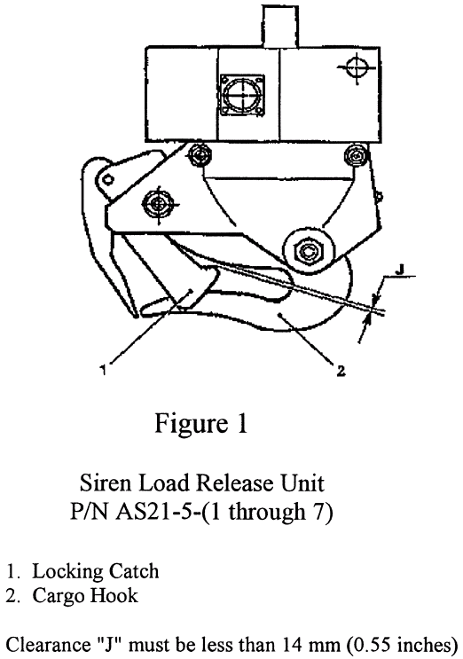
(b) An alternative method of compliance or adjustment of the compliance time that provides an acceptable level of safety may be used if approved by the Manager, Regulations Group, Rotorcraft Directorate, FAA. Operators shall submit their requests through an FAA Principal Maintenance Inspector, who may concur or comment and then send it to the Manager, Regulations Group.

Note 2: Information concerning the existence of approved alternative methods of compliance with this AD, if any, may be obtained from the Regulations Group.

(c) Special flight permits will not be issued allowing use of the affected cargo hook.

(d) This amendment becomes effective on September 6, 2002.

Note 3: The subject of this AD is addressed in Direction Generale De L'Aviation Civile, (France) AD 2001-318(A), dated July 25, 2001.

FOR FURTHER INFORMATION CONTACT: Jim Grigg, Aviation Safety Engineer, FAA, Rotorcraft Directorate, Rotorcraft Standards Staff, Fort Worth, Texas 76193-0110, telephone (817) 222-5490, fax (817) 222-5961.
Issued in Fort Worth, Texas, on July 24, 2002.
Eric Bries,
Acting Manager, Rotorcraft Directorate, , Aircraft Certification Service.
[FR Doc. 02-19488 Filed 8-1-02; 8:45 am]
BILLING CODE 4910-13-P

